[Lecture 2 Slides](https://drive.google.com/file/d/1xkk7w7GshPtbQ2id3P9qSLdwQNp7q7Mi/view?usp=sharing)

**Reversibility:**

Reversible gate: Preserves all the information. E.g.: NOT.

Non-reversible gate: Doesn’t preserve all the information. E.G.: OR

You represent a qubit by putting it inside a ket  **| ⟩**  
E.g

|  |  |
| --- | --- |
| Bit | Qubit |
| 1 | |1〉 |
| 0 | |0〉 |

A qubit state can be expressed as follows:

**|ψ**〉 **= 𝝰 |0**〉 **+𝛃|1**〉

Where,          

probability of measuring |0⟩ : |𝛼|^2

probability of measuring |1⟩ : |𝛽|^2

Quantum Gates:

**X-gate**: Bit-flip (Analog to the NOT gate)

|0〉 => |1〉

|1〉 => |0〉

Truth table:

|  |  |
| --- | --- |
| In | Out |
| |0〉 | |1〉 |
| |1〉 | |0〉 |

**Z-Gate: Phase gate** (No analog classical gate?)

Z|0〉 =  |0〉

Z|1〉 = **-** |1〉

Truth table:

|  |  |
| --- | --- |
| In | Out |
| |0〉 | |0〉 |
| |1〉 | - |1〉 |

**Hadamard (H) gate:** Create a 50-50 superposition from |0〉and |1〉 (No analog classical gate)

H|0〉 = √(0.5) |0〉+√(0.5) |1〉

H|1〉 = √(0.5) |0〉-√(0.5) |1〉

|  |  |
| --- | --- |
| In | Out |
| H |0〉 | √(0.5)|0〉+√(0.5)|1〉 |
| H |1〉 | √(0.5)|0〉 **-** √(0.5)|1〉 |

Courtesy of Lucas D. #1336 :

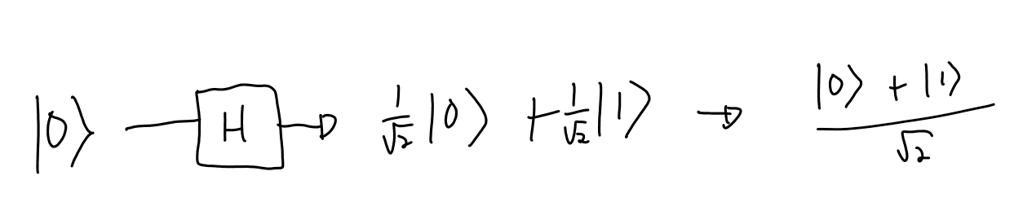

Circuit composer: <https://quantum-computing.ibm.com/>

H (H|0⟩) = |0⟩

Q gates works to each state of superposition:

* Separately
* In parallel

Demonstration

X|𝜓⟩ = X (𝛼|0⟩ + 𝛽|1⟩) = 𝛼 (X|0⟩) + 𝛽 (X|1⟩)  = 𝛼 |1⟩ + 𝛽|0⟩

Quantum interference: **|1>** +|0⟩  + |0⟩  **- |1>**

Quantum states can be amplified or canceled (by interference)

In Quantum algorithms, we want an equal superposition of each state to after amplify/cancel one or each other for the result we want. But there is also a chance of errors.

Superposition table:

………….

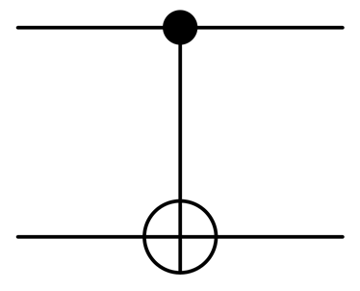

CNOT (Controlled NOT):

if the control qubit is 0, does nothing

if the control qubit is 1, flip the target qubit

|  |  |  |  |
| --- | --- | --- | --- |
| IN | | OUT | |
| C | T | C | T |
| |0⟩ | |0⟩ | |0⟩ | |0⟩ |
| |0⟩ | |1⟩ | |0⟩ | |1⟩ |
| |1⟩ | |0⟩ | |1⟩ | |1⟩ |
| |1⟩ | |1⟩ | |1⟩ | |0⟩ |

Entanglement: Let’s say QA and QB are entangled

QA = |0⟩  -> QB = |0⟩

QA = |1⟩  -> QB = |1⟩

Applications:

* Quantum Teleportation
* Quantum Cryptography
* Superdense Coding
* Quantum speedups

**Creating an entanglement:**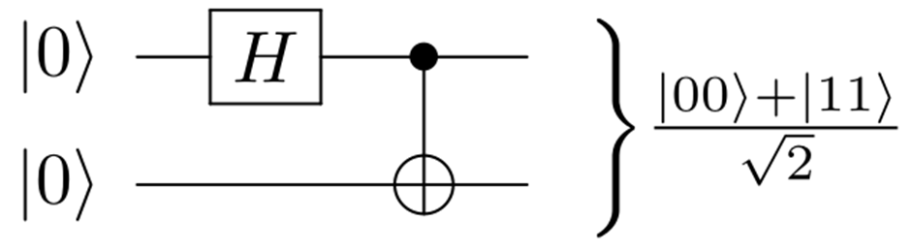

Entanglement circuit: apply a Hadamard gate and then a CNOT gate

<https://quantum-computing.ibm.com/composer/new-experiment?initial=N4IgdghgtgpiBcIBiBLATgZwC4AIDG6eAriliADQgCOEGUCIA8gAoCiAcgIoCCAygLI4ATADoADAG4AOmBRg8AGyIATGDinUYClACMAjCLl4N0sDKpoYAcxxUA2kIC6pvJZt4HzmTIAWtu2Je8gAe-oHk9npBsLRElv5ROAC0AHz4dlGmMRhxavaByWkegRIUIKoYrigADlgoAPZgDCAAvkA>

These notes are a mess (T _ T) …… yup lmao

You guys did really great tho

Thanks everyone!

Thank uu